1. Introduction to Virtualization

Definition of Virtualization
Virtualization is a technology that enables the creation of multiple simulated environments or dedicated resources from a single physical hardware system. It involves abstracting and allocating computing resources such as processors, memory, storage, and networking to multiple virtual instances, allowing them to function independently. This is achieved through hypervisors or virtual machine monitors (VMMs), which create and manage virtual machines (VMs) or containers, ensuring efficient resource utilization.
Instead of relying on separate hardware for different applications or operating systems, virtualization allows organizations to maximize their IT infrastructure by running multiple environments on a single physical server. This enhances flexibility, reduces hardware costs, and improves system efficiency.
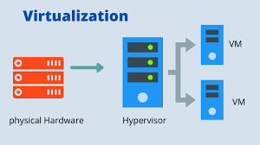
Fig. Virtualization

Importance and Benefits of Virtualization

1. Efficient Resource Utilization: Traditionally, IT infrastructures required multiple physical servers to run different applications and operating systems, leading to underutilized resources. Virtualization consolidates workloads, allowing multiple virtual machines to share the same physical hardware, maximizing resource usage.

2. Cost Savings: By reducing the need for multiple physical servers, organizations can save on hardware, power consumption, cooling, and maintenance costs. Virtualization enables businesses to deploy and manage applications more efficiently without significant capital investment.

3. Scalability and Flexibility: Virtualized environments allow businesses to scale their IT infrastructure quickly. New virtual machines can be created, configured, and deployed in minutes, making it easier to meet dynamic business demands.

4. Disaster Recovery and Business Continuity: Virtualization simplifies disaster recovery by enabling quick backup and restoration of virtual machines. Organizations can create snapshots of virtual environments and store them in multiple locations, ensuring minimal downtime in case of system failures..

Types of Virtualization:
Virtualization can be categorized into different types based on the resources being virtualized. These include:

1. Server Virtualization
Server virtualization allows multiple virtual servers to run on a single physical machine. Each virtual server operates independently with its own operating system and applications. This reduces the number of physical servers required, leading to better resource allocation and cost savings. Examples include VMware vSphere, Microsoft Hyper-V, and KVM (Kernel-based Virtual Machine).

2. Network Virtualization
Network virtualization abstracts network resources, allowing multiple virtual networks to coexist on the same physical network infrastructure. This enables network segmentation, enhanced security, and better management. Examples include VMware NSX, Cisco ACI, and OpenFlow-based SDN (Software-Defined Networking).

3. Storage Virtualization
Storage virtualization aggregates physical storage resources and presents them as a unified system. This simplifies storage management, improves performance, and enhances fault tolerance. Examples include VMware vSAN, Dell EMC VxRail, and NetApp ONTAP.

4. Desktop Virtualization
Desktop virtualization enables users to access their desktops remotely from any device. Instead of relying on a physical desktop, a virtual desktop infrastructure (VDI) hosts operating systems and applications on centralized servers. Examples include Citrix Virtual Apps and Desktops, Microsoft Azure Virtual Desktop, and VMware Horizon.

5. Application Virtualization
Application virtualization allows applications to run in a virtual environment without being installed on the local operating system. This prevents software conflicts and ensures compatibility across different devices. Examples include Microsoft App-V, VMware ThinApp, and Citrix XenApp.

2. Overview of Virtualization Technologies
Virtualization technologies form the foundation of modern cloud computing and IT infrastructure by enabling multiple virtual environments to run on a single physical machine. These technologies optimize resource allocation, improve scalability, and enhance security. This section explores hypervisors (Type 1 and Type 2), Virtual Machines (VMs) vs. Containers, and key features of virtualization.

2.1 Hypervisors (Type 1 and Type 2)
A hypervisor, also known as a Virtual Machine Monitor (VMM), is a software layer that enables multiple virtual machines (VMs) to share the same physical hardware. It manages the allocation of CPU, memory, storage, and networking resources among the virtual machines, ensuring they operate independently.

Types of Hypervisors

1. Type 1 Hypervisor (Bare-Metal Hypervisor)
- Installed directly on the physical hardware without requiring an underlying operating system.
- Offers better performance, security, and efficiency since it has direct access to hardware resources.
- Commonly used in enterprise and cloud environments.
Examples:
- VMware ESXi
- Microsoft Hyper-V
- Xen (used by AWS)
- KVM (Kernel-based Virtual Machine, used in Linux environments)

2. Type 2 Hypervisor (Hosted Hypervisor)
- Runs as an application on an existing operating system.
- Easier to install and manage but less efficient than Type 1 hypervisors because it relies on the host OS.
- Typically used for testing, development, and personal use.
Examples:
- VMware Workstation
- Oracle VirtualBox
- Parallels Desktop (for macOS)

Virtualization Platforms: AWS, GCP, Microsoft Azure, and VMware

1. Amazon Web Services (AWS)
AWS (Amazon Web Services) is a leading cloud computing platform offering a wide range of virtualization and cloud services. It provides Infrastructure as a Service (IaaS), Platform as a Service (PaaS), and Software as a Service (SaaS) solutions. AWS uses Xen, KVM, and Nitro hypervisors for virtualization, enabling businesses to run virtual machines, containers, and serverless applications.
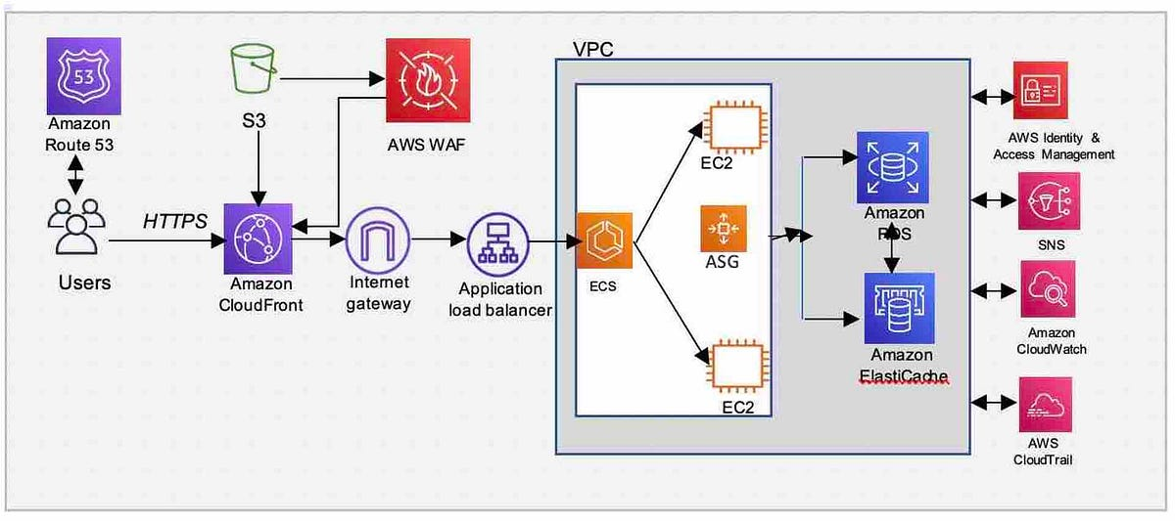

Advantages:
✅ Scalability – Auto-scaling features allow dynamic resource allocation.
✅ Pay-as-you-go Pricing – Reduces costs as users pay only for what they use.
✅ Global Reach – Offers multiple availability zones for better redundancy.
✅ Wide Service Range – Includes compute (EC2), storage (S3), database (RDS), and AI services.

Disadvantages:
❌ Complex Pricing Structure – Pricing can be difficult to estimate.
❌ Steep Learning Curve – Requires expertise to configure and optimize services.
❌ Data Transfer Costs – High costs for data transfer between regions.

Examples of Use Cases:
- Netflix uses AWS for content streaming and global infrastructure.
- NASA stores and processes satellite data using AWS cloud services.
- Airbnb manages its massive booking system using AWS infrastructure.

2. Google Cloud Platform (GCP)

GCP (Google Cloud Platform) is a cloud computing service that provides virtual machines, containers, databases, and AI-driven applications. It primarily uses KVM-based virtualization for its Compute Engine and integrates well with Kubernetes for containerized workloads.

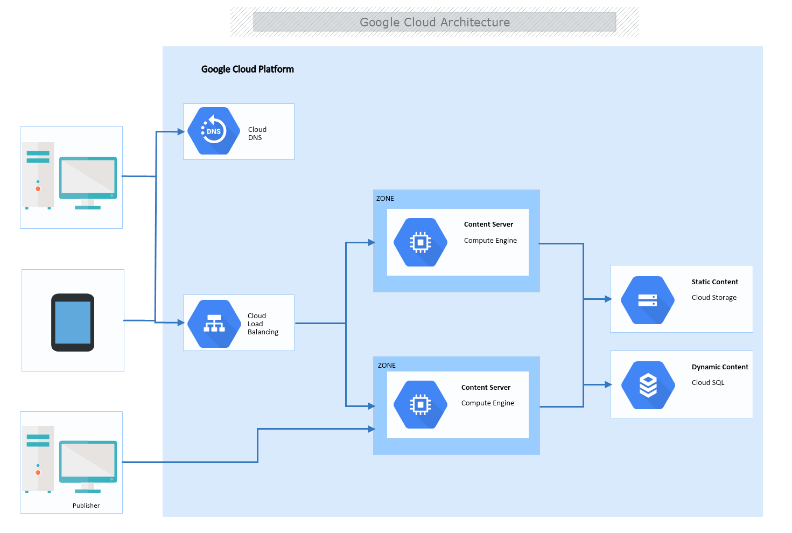

Advantages:
✅ Live Migration of VMs – Ensures zero downtime during maintenance.
✅ Competitive Pricing – Offers sustained usage discounts and flexible pricing..
✅ Strong Kubernetes Integration – Google is the creator of Kubernetes, making GCP ideal for containerized applications.

Disadvantages:
❌ Fewer Data Centers – Limited global availability compared to AWS and Azure.
❌ Less Enterprise Adoption – AWS and Azure dominate enterprise markets.
❌ Smaller Service Ecosystem – Offers fewer services than AWS or Azure.

Examples of Use Cases:
- Twitter uses GCP for analytics and data processing.
- Spotify runs its music streaming and recommendation engine on GCP.
- PayPal uses GCP for fraud detection and data security.

3. Microsoft Azure
Microsoft Azure is a cloud computing platform offering virtual machines, databases, and AI services. It supports both Hyper-V and KVM hypervisors for virtualization and integrates well with Windows-based enterprise applications.
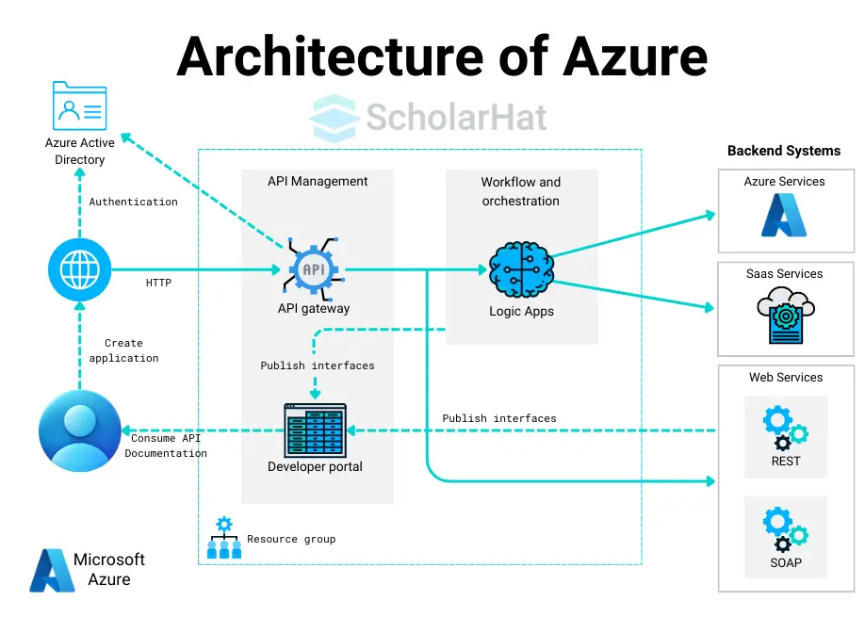

Advantages:
✅ Best for Windows Workloads – Optimized for Microsoft applications like Windows Server, SQL Server, and Active Directory.
✅ Hybrid Cloud Support – Allows integration with on-premises data centers using Azure Arc.
✅ Strong DevOps Support – Seamless integration with GitHub and DevOps tools.

Disadvantages:
❌ Higher Learning Curve – Requires expertise in Microsoft technologies.
❌ Cost Management Issues – Unexpected costs if resources aren’t optimized.
❌ Complex UI – Azure’s dashboard can be confusing for new users.

Examples of Use Cases:
- LinkedIn runs on Microsoft Azure for global infrastructure.
- BMW uses Azure for smart manufacturing and IoT solutions.
- Starbucks leverages Azure AI for customer personalization.

4. VMware
VMware is a pioneer in virtualization technology, offering solutions like vSphere, ESXi, and vCenter for creating and managing virtualized environments. It specializes in on-premises, private cloud, and hybrid cloud solutions.
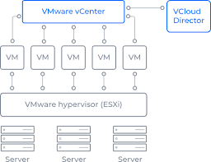

Advantages:
✅ Hybrid & Multi-Cloud Support – Works across private, public, and hybrid clouds.
✅ Live Migration – Allows seamless movement of VMs without downtime.
✅ Scalability & Resource Optimization – Efficient use of server resources.

Disadvantages:
❌ Expensive Licensing Costs – Higher costs compared to cloud providers like AWS and GCP.
❌ Requires Dedicated Infrastructure – On-premises deployments need hardware investment.
❌ Not Cloud-Native – Primarily designed for traditional IT environments rather than modern cloud applications.

Examples of Use Cases:
- Dell EMC uses VMware for cloud and server virtualization.
- Government agencies rely on VMware for secure on-premises virtualization.
- Large enterprises use VMware for private cloud deployments.

Comparison Table: AWS vs. GCP vs. Azure vs. VMware
Feature | AWS | GCP | Microsoft Azure | VMware
Virtualization Type | Xen, KVM, Nitro | KVM | Hyper-V, KVM | ESXi, vSphere
Deployment Model | Public cloud, hybrid cloud | Public cloud | Public cloud, hybrid cloud, on-premises | On-premises, private cloud, hybrid cloud
Best for | General cloud computing, large-scale workloads | AI, ML, analytics, Kubernetes | Windows-based enterprise applications, hybrid cloud | Enterprise IT, private data centers
Pricing Model | Pay-as-you-go, Reserved Instances, Spot Instances | Sustained usage discounts, Committed use contracts | Pay-as-you-go, Reserved Instances, Hybrid benefits | Licensing-based, subscription model
Scalability | Highly scalable, auto-scaling support | Scalable with strong Kubernetes support | Scales well with enterprise applications | Scalable but requires on-premises infrastructure
Hybrid Cloud Support | AWS Outposts for on-premises integration | Anthos for hybrid and multi-cloud management | Strong hybrid cloud support with Azure Arc | VMware Cloud on AWS, Azure VMware Solution
AI & Machine Learning | AWS SageMaker, Deep Learning AMIs | TensorFlow, Vertex AI, BigQuery ML | Azure AI, Cognitive Services, ML Studio | Limited AI/ML features
Container Support | Amazon ECS, Amazon EKS (Kubernetes) | Google Kubernetes Engine (GKE) | Azure Kubernetes Service (AKS) | VMware Tanzu for containerized workloads
High Availability & Reliability | Multiple availability zones, backup & DR services | Live VM migration, strong disaster recovery | High availability zones, backup & site recovery | HA clustering, vMotion for live VM migration
Integration with Third-Party Services | Marketplace with extensive third-party apps | Limited compared to AWS and Azure | Deep integration with Microsoft apps | Strong integration with enterprise software
DevOps & CI/CD Support | AWS CodePipeline, CodeDeploy | Cloud Build, Cloud Source Repositories | Azure DevOps, GitHub Actions | VMware DevOps with automation tools
Use Cases | Netflix, Airbnb, NASA | Spotify, Twitter, PayPal | LinkedIn, BMW, Starbucks | Dell EMC, government agencies, enterprises

CONCLUSION
Virtualization platforms play a crucial role in modern IT infrastructure by enabling efficient resource utilization, scalability, and cost savings. AWS, GCP, Microsoft Azure, and VMware are leading providers, each offering unique strengths. AWS is ideal for scalability and global reach, GCP excels in AI and data analytics, Azure integrates seamlessly with Windows-based enterprises, and VMware

